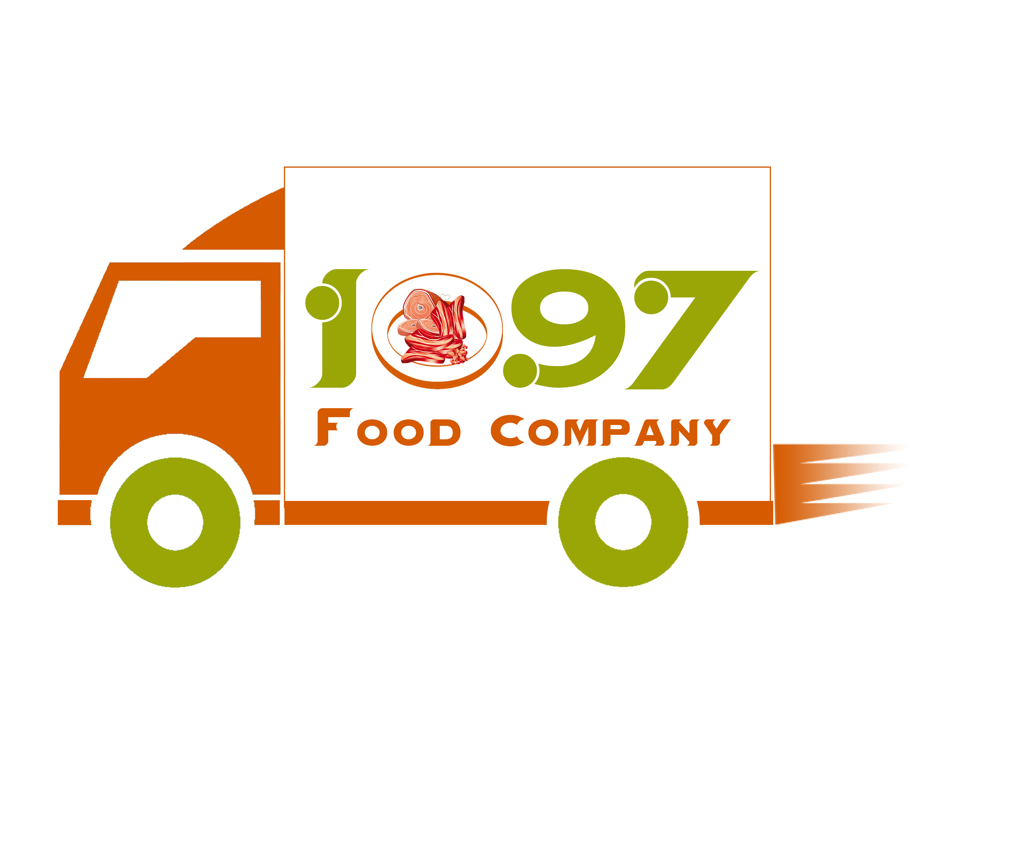

1097 a food Company INC

Credit Application for a Business Account
Business Contact Information
Title:
Company name:
Phone: | Fax: | E-mail:
Registered company address:
City: |  | State: | ZIP Code:
Date business commenced:
Sole proprietorship: | Partnership: | Corporation: | Other:
Business and Credit Information
Primary business address:
City: |  | State: | ZIP Code:
How long at current address?
Telephone: | Fax: | E-mail:
Bank name:
Bank address: |  | Phone:
City: |  | State: | ZIP Code:
Type of account: | Account number:
Savings
Checking
Credit Card #
Business/trade references
Company name:
Address:
City: |  | State: | ZIP Code:
Phone: | Fax: | E-mail:
Type of account:
Company name:
Address:
City: |  | State: | ZIP Code:
Phone: | Fax: | E-mail:
Type of account:
Agreement
- All invoices are to be paid 30 days from the date of the invoice. Accounts not paid in this frame will be charged 3.5% interest rate per month and future orders will be on a C.O.D. Should collection or legal action be required to collect past dues, fees for such action will be added to your account.
- Claims arising from invoices must be made within seven working days.
- By submitting this application, you authorize to make inquiries into the banking and business/trade references that you have supplied.

Signatures

Title:

Date:
Title:  Date: |  | Title:  Date:

